HEIDENHAIN at automatica 2023:
The next generation of inductive scanning

HEIDENHAIN is showcasing its next generation of inductive scanning technology, embodied in the ECI 1122 and EQI 1134 rotary encoders. Designed for high-performance automation, these new encoders feature low noise, low speed ripple and extensive operating data. Thanks to their EnDat 3 interface, they can be connected using the HMC 2 single-cable solution.

On the outside, the new HEIDENHAIN ECI 1122 and EQI 1134 inductive rotary encoders look identical to the other models within the series. But their specs tell a different story, especially their improved singleturn position resolution of 22 bits. This higher resolution significantly reduces the speed ripple and the position noise of the motor. The new ECI 1122 and EQI 1134 rotary encoders are perfect solutions for the current trends in automation toward higher accuracy, performance, process reliability and cost efficiency.
At the heart of the new rotary encoders and their inductive scanning technology is a new ASIC with 180-nanometer technology, providing the perfect combination of reliability, robustness and miniaturization. Another highlight and a completely new approach for a sensor ASIC is their application-specific integrated processor (ASIP). The ASIP enables the collection of operating data about the encoder and the motor to a new extent and at a critical location in the overall system. After all, no other electronic device is located so close to the motor. The collected operating data, including loads, operating times and motor temperatures, provide a reliable basis for optimizing operation, maximizing service life, streamlining maintenance and much more.
For the first time, this new generation of inductive rotary encoders implements EnDat 3 directly on a scanning ASIC as a single-chip solution. This enables use of the HMC 2 single-cable solution, which combines data and power wires in a single cable extending from the motor to the control. The benefits are less cabling, higher data rates and reduced space requirements. But that’s not all. The new ASIC, with its high-performance EnDat 3 interface, sets the stage for future developments, such as acceleration sensors that could feed directly into the EnDat 3 signal. And unlike previous solutions, no additional sensor boxes (or their cables) are needed for communication with the control.
This next-generation inductive measurement technology won’t be limited to the ECI 1122 and EQI 1134 rotary encoders. Over time, it will be implemented in the full range of HEIDENHAIN inductive encoders. Its countless options, including an SSI interface or a programmable TTL interface as an alternative to EnDat 3, promise a host of benefits.

HEIDENHAIN at automatica 2023 in Munich: Hall B6, Booth 303

For more information, visit:
robotics.heidenhain.com
www.heidenhain.de

Contact person for the trade press:
Ulrich Poestgens
Tel.: +49 8669 31-4154
poestgens@heidenhain.de

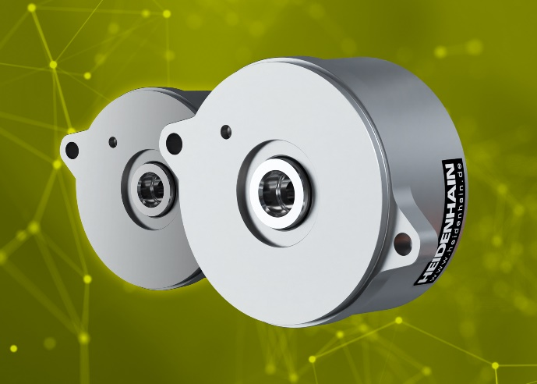 | The ECI 1122 and EQI 1134 rotary encoders from HEIDENAIN: the next generation of inductive scanning and the EnDat 3 interface provide key benefits for compact motors in demanding automation applications.
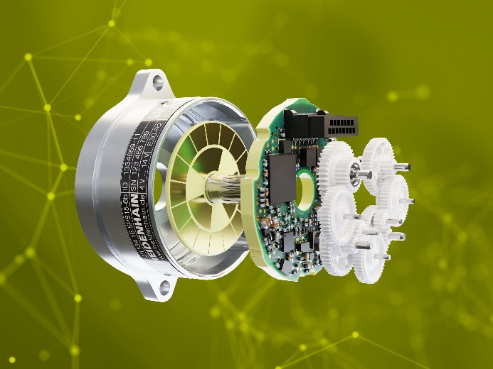 | The inner workings of the EQI 1134 multiturn variant of the new inductive rotary encoder generation from HEIDENHAIN (from left to right): flange, rotor with measuring standard, electronics, multiturn gearing. The new ASIC incorporates position feedback, functional safety for SIL 3 monitoring, other serial interfaces along with EnDat 3, an on-chip temperature sensor, connectivity for external temperature sensors and a data management processor.

